**Name: LAMIA ALSHUWAIER**

**Student ID: 201912117**

**Exercise 1: Write an SQL statement to create the following tables in a database called “University”**

LECTURERS

|  |  |  |
| --- | --- | --- |
| **Key type** | **optionality** | **Column name** |
| **PK** | **\*** | **Lecturer_ID** |
|  | **\*** | **Lecturer_Firstname** |
|  | **0** | **Lecturer_last name** |
|  | **0** | **Employee type** |
|  | **0** | **Grade** |
|  | **0** | **Organization** |

COURSES

|  |  |  |
| --- | --- | --- |
| **Key type** | **optionality** | **Column name** |
| **PK** | **\*** | **Course_ID** |
|  | **\*** | **Course_name** |
|  | **0** | **Description** |
| **FK** | **0** | **Lecturer_ID** |

SCHEDULES

|  |  |  |
| --- | --- | --- |
| **Key type** | **optionality** | **Column name** |
| **PK** | **\*** | **Schedule_ID** |
|  | **\*** | **term** |
| **FK** | **0** | **Student_ID** |
| **FK** | **0** | **Course_ID** |

STUDENTS

Lecturers

|  |  |  |
| --- | --- | --- |
| **Key type** | **optionality** | **Column name** |
| **PK** | **\*** | **Student_ID** |
|  | **\*** | **Student_Firstname** |
|  | **\*** | **Student_last name** |
|  | **\*** | **Enrollement_status** |
|  | **\*** | **Study_year** |

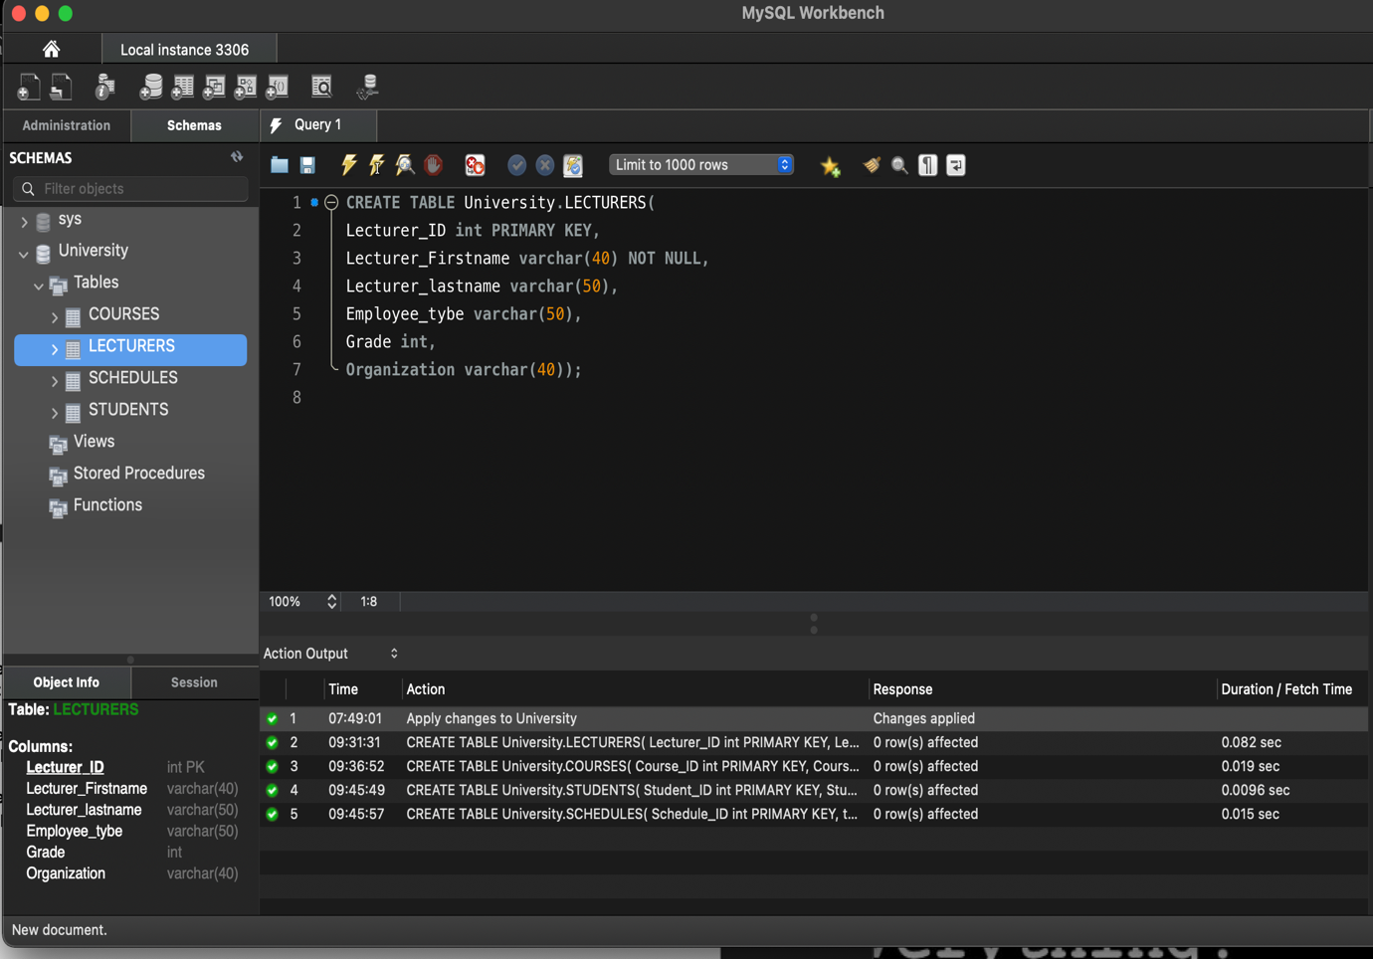

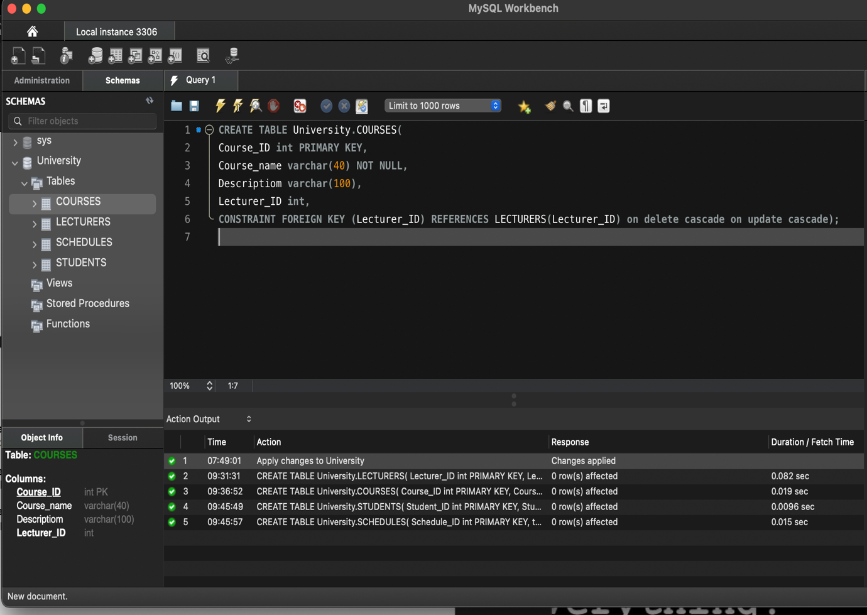

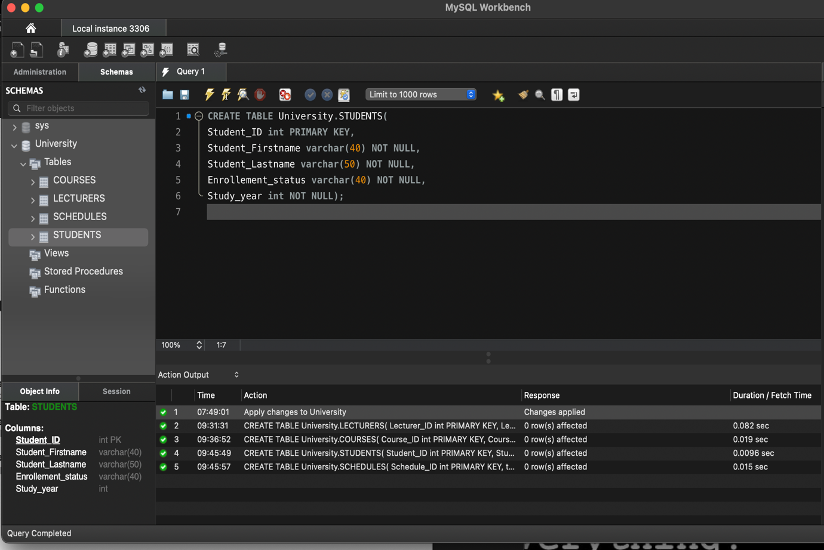

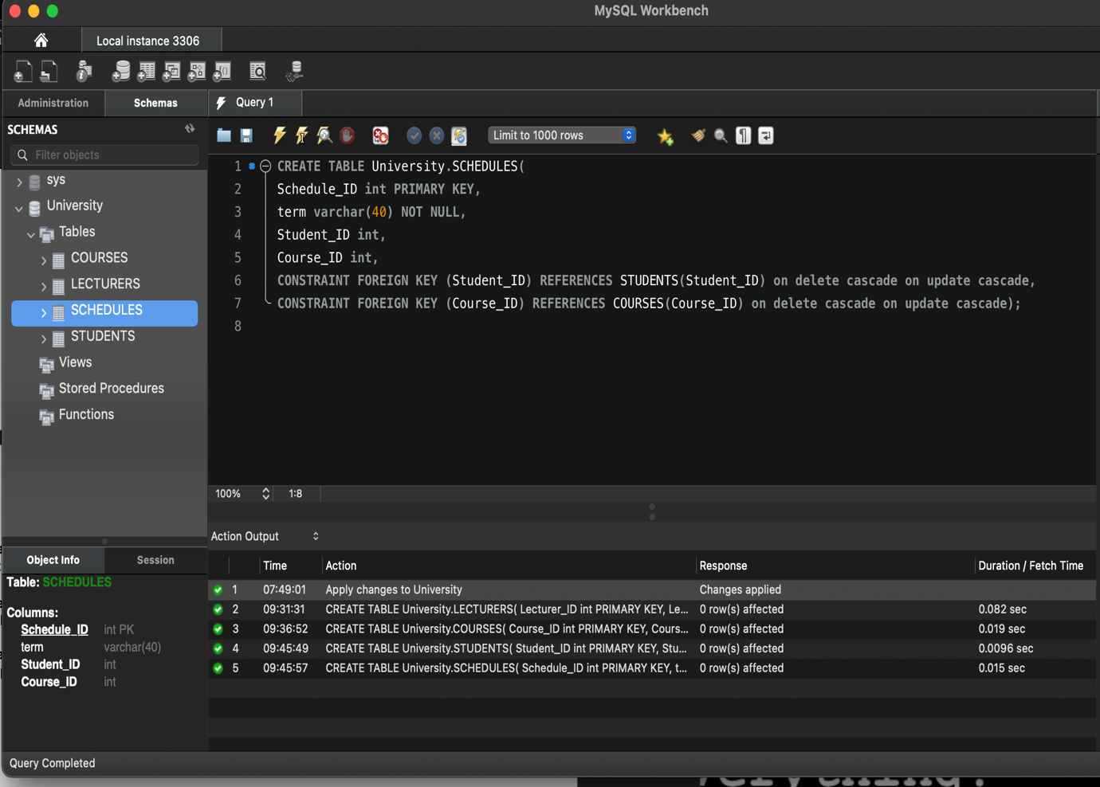

**Exercise 2: Write an SQL Statement that add a new column called “Contact_number” to the STUDENTS table.**

**Exercise 3: Write an SQL Statement that drop the column “Description” from the table COURSES**

**Exercise 4: Write an SQL statement that changes the maximum number of character in the column “Student_Firstname” from table STUDENT to 100.**

